**Community Site for a College English course**

-WordPress site developed locally with Local by Flywheel, Text Editor, Terminal

-Languages: HTML, CSS, PHP, JavaScript

Home Page (top half desktop)

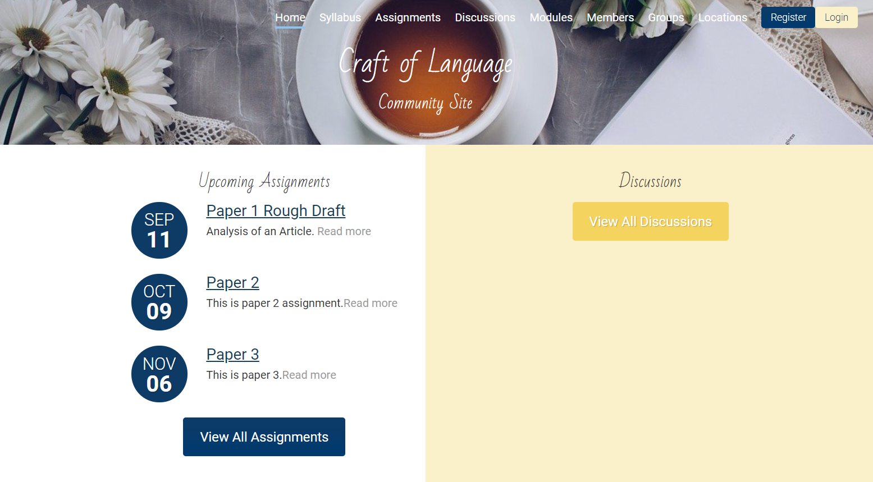

Home Page (bottom half desktop)



Home Page (mobile/responsive) Custom Login Screen

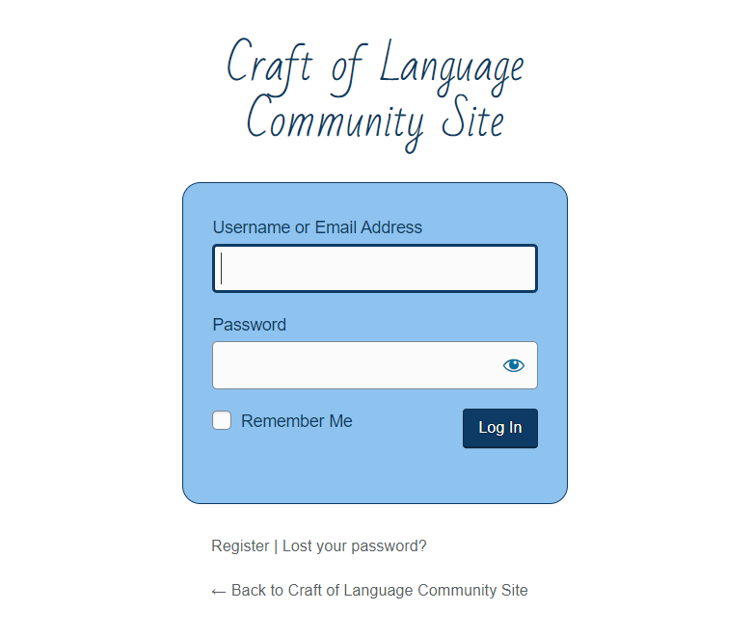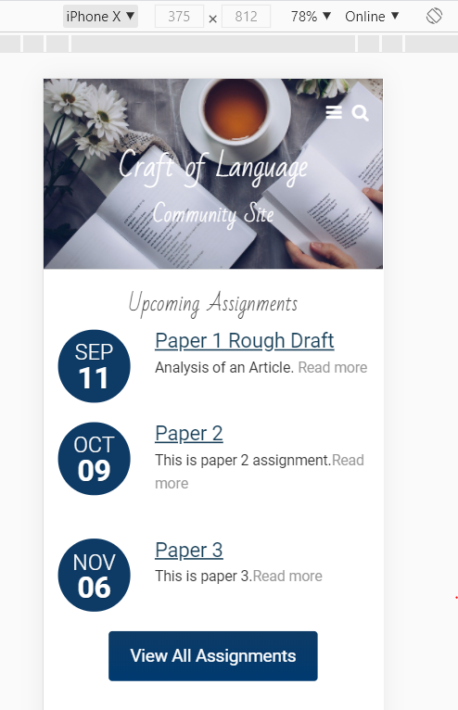

Hoverable User Menu when Logged In

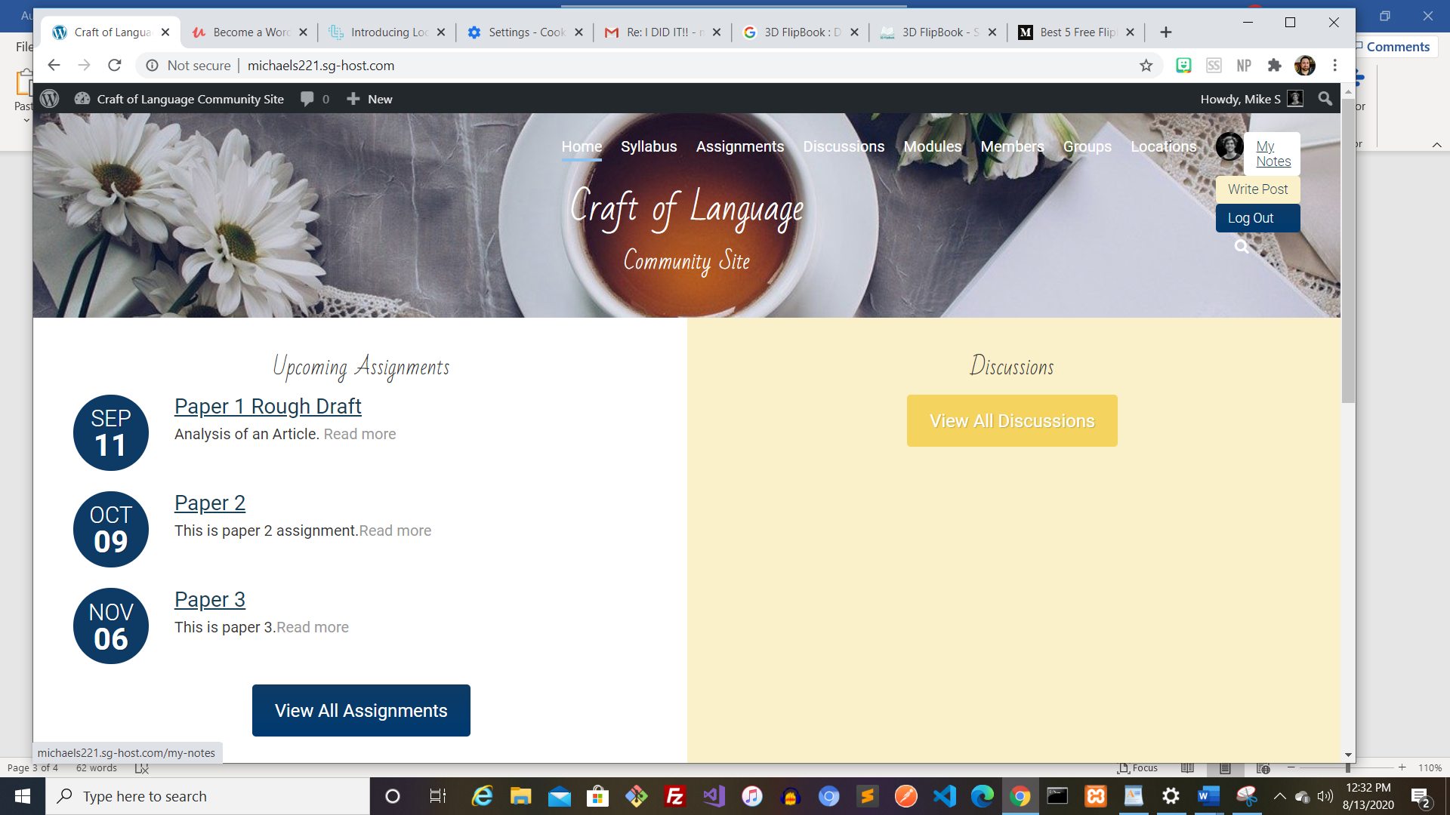

User Profile Page (with gravatar, custom background, and posts/comments stream)

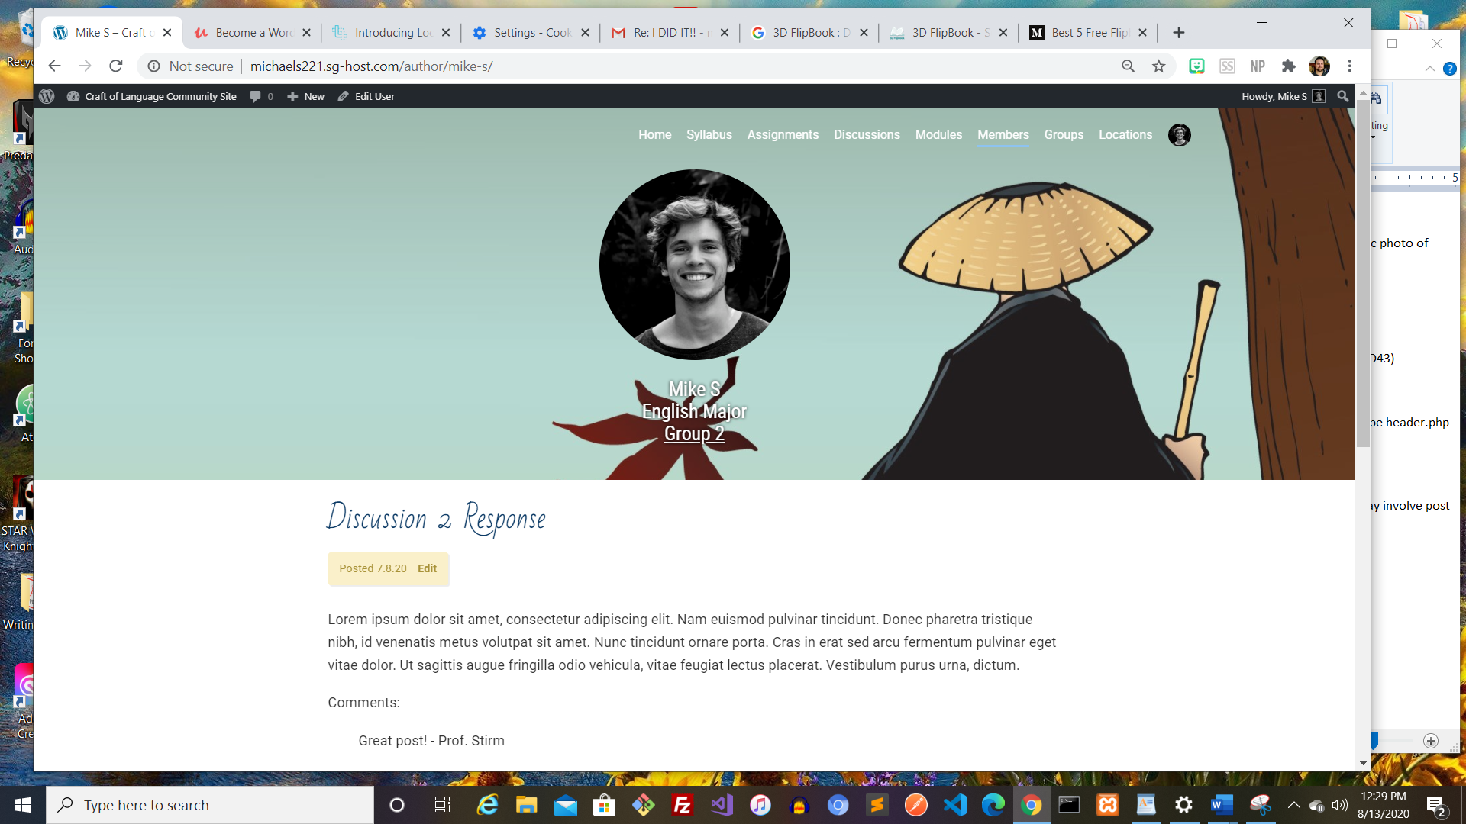

My Notes Feature utilizing WordPress’s REST API

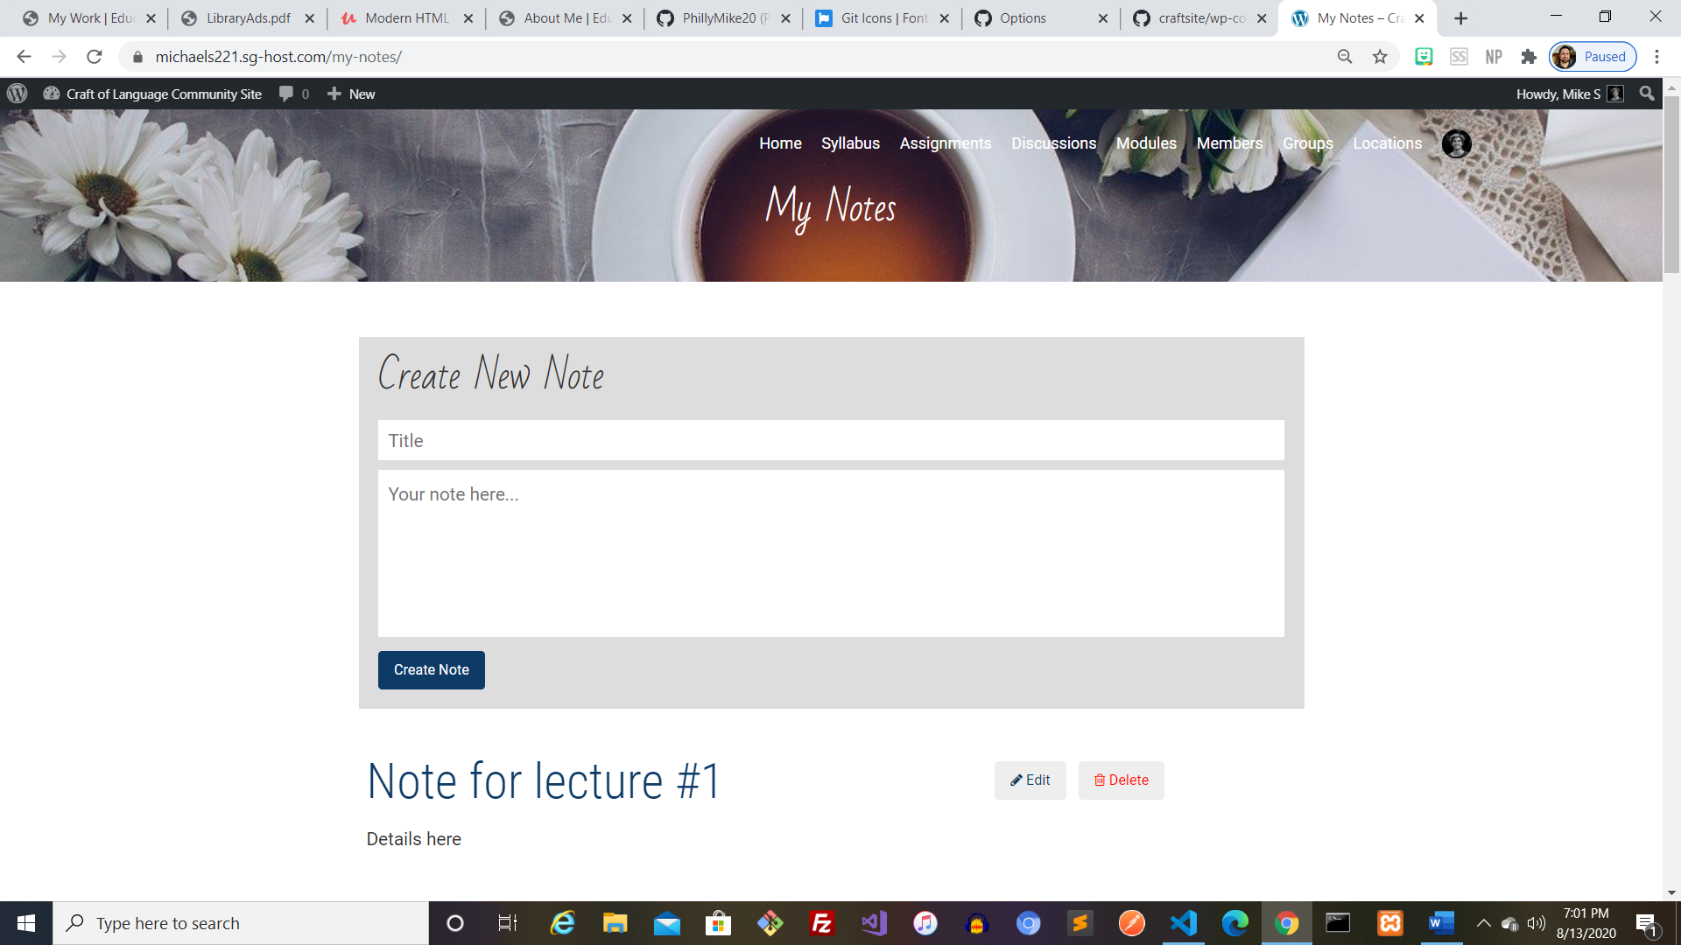

Discussion Page with Post Streams

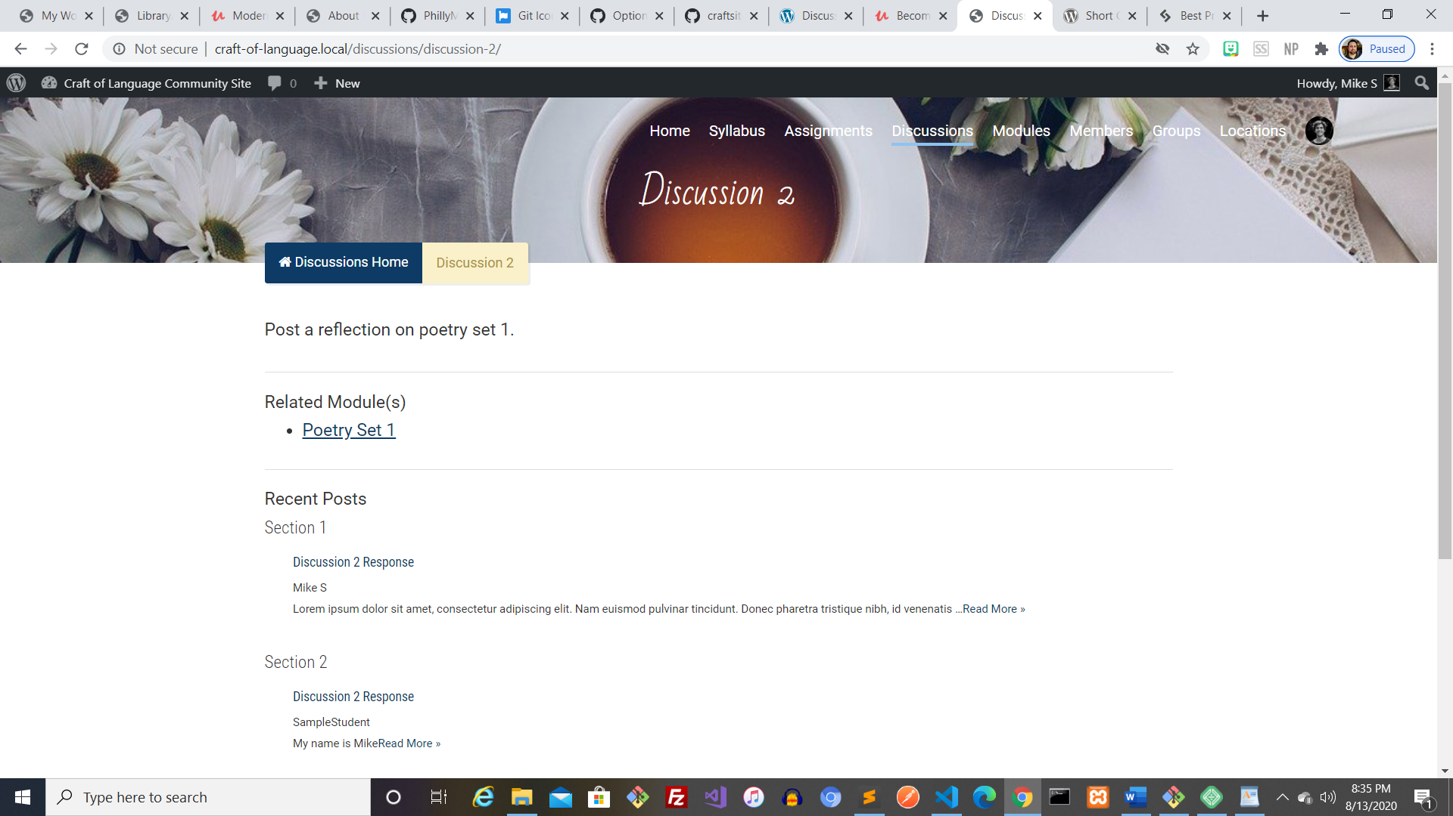

Class Poetry Collection Page with FlipBook Plugin

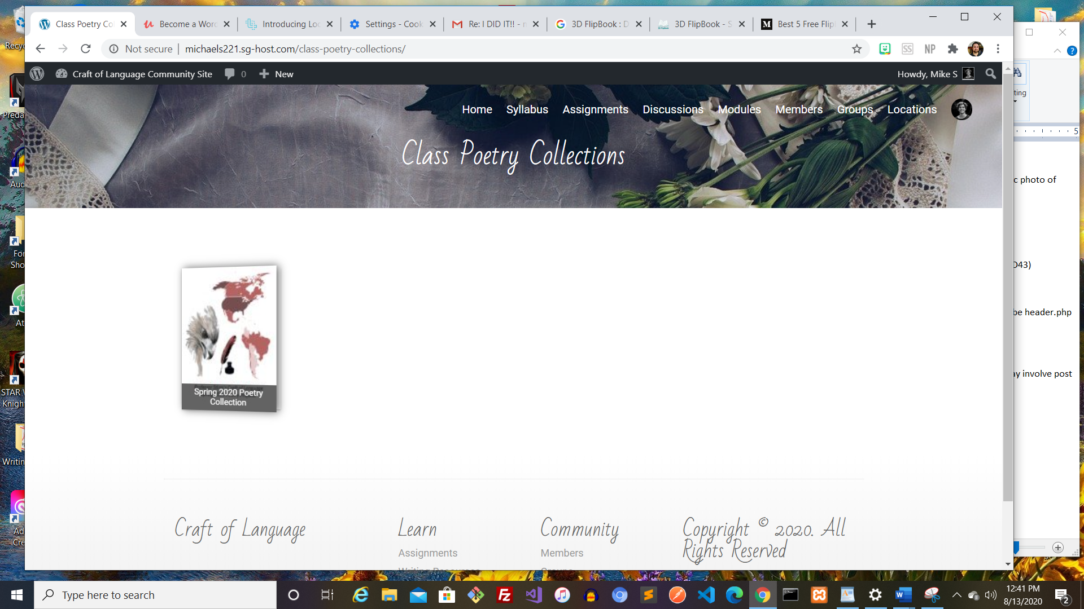

Private GitHub Repository

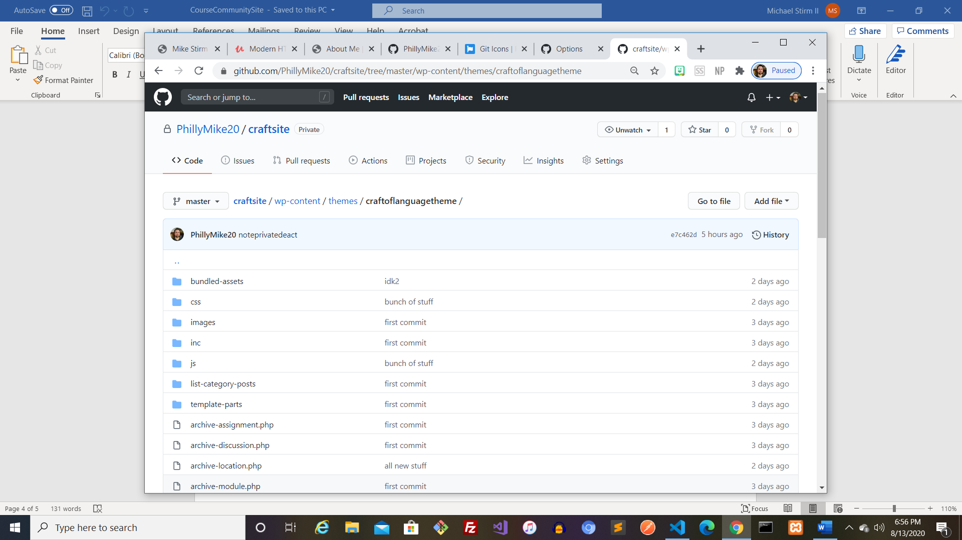

Remaining:

~~-My Notes feature (fix notes displaying Private first)~~

~~-Discussion Page w/ post streams~~

-Assignment Page with related module (Displayed via Custom Field relationship)

-Class pages with Student Avatars (hyperlinked to profile pages) Displayed

-Group pages with Member Avatars and projects

-Locations page incorporating Google Maps JavaScript API with relevant course locations (classrooms, library, writing center) marked on map

-‘Submit a Paper’ Page with Submission Form